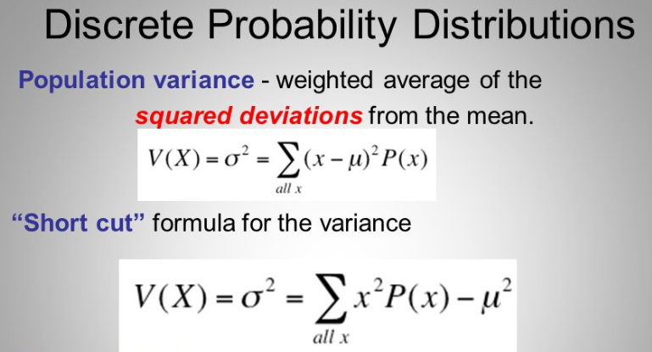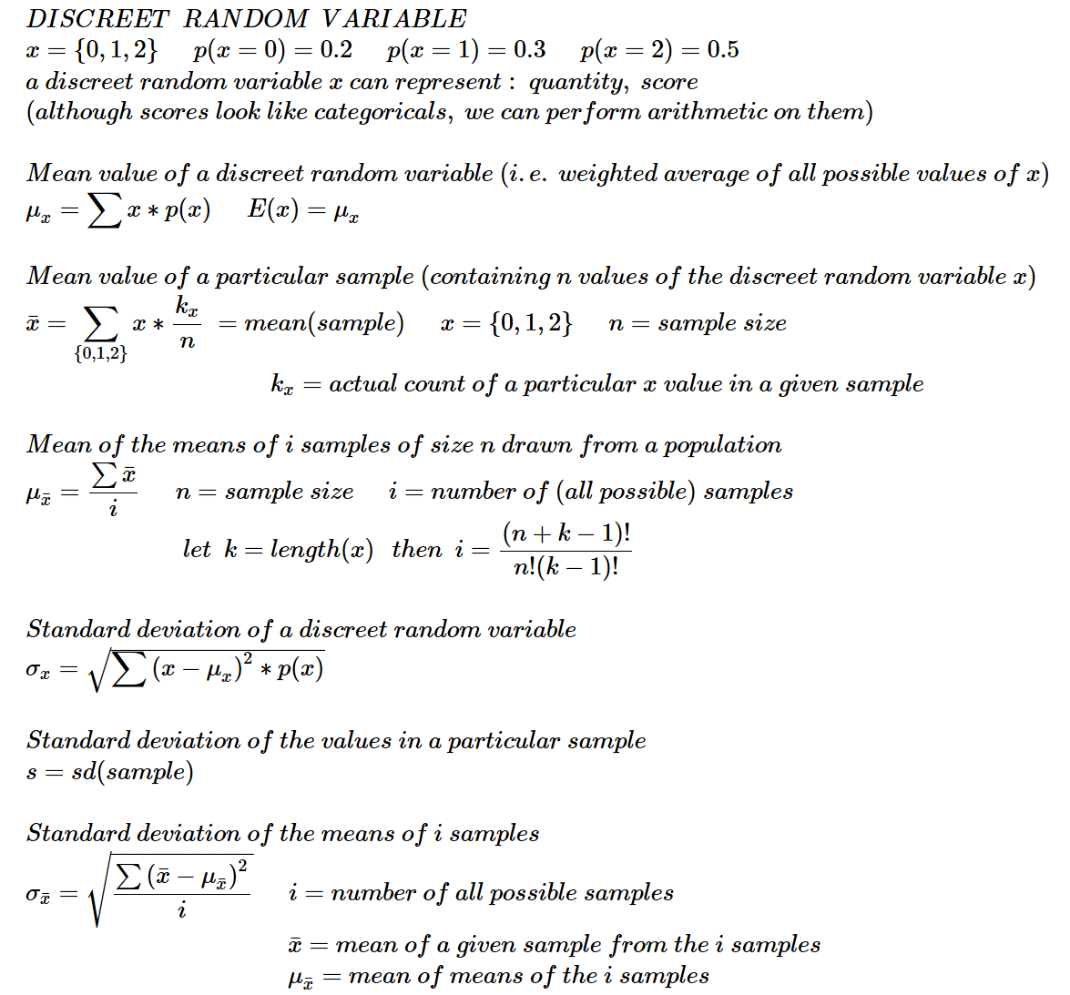

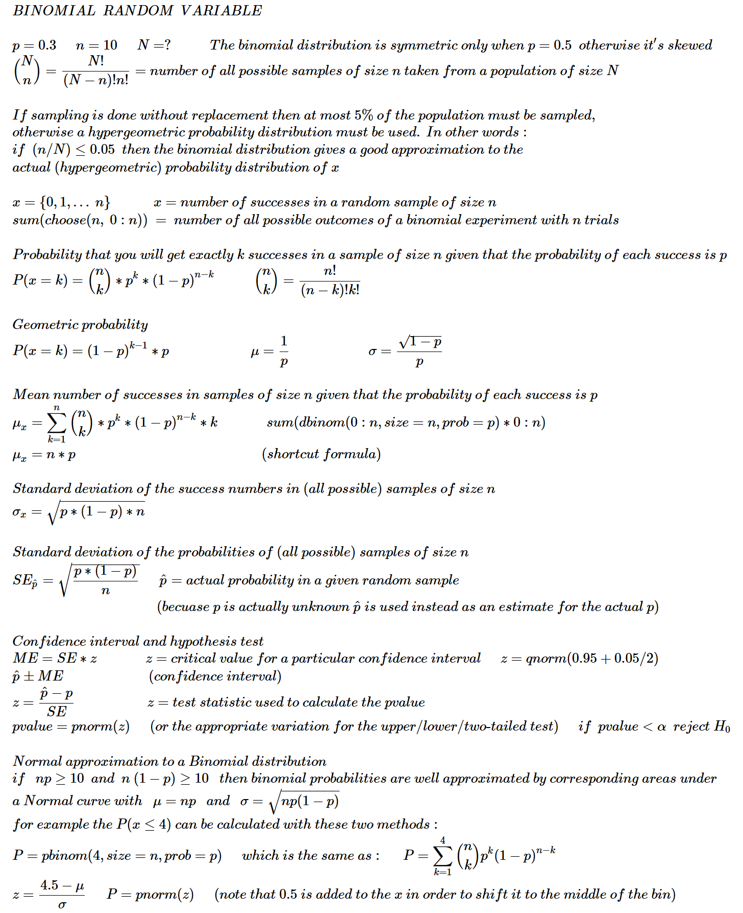

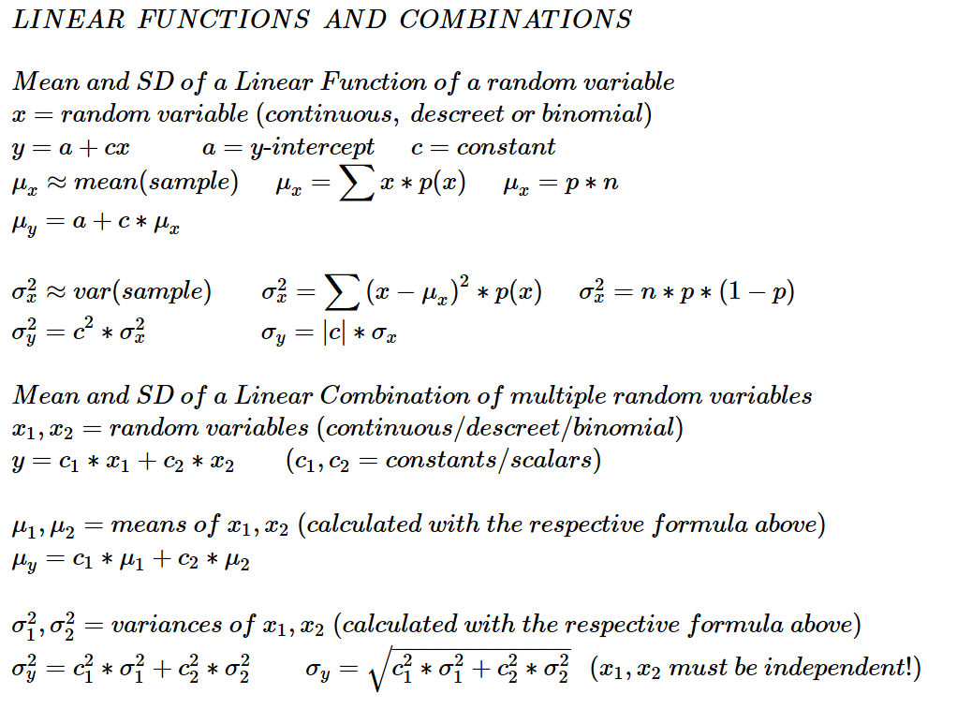

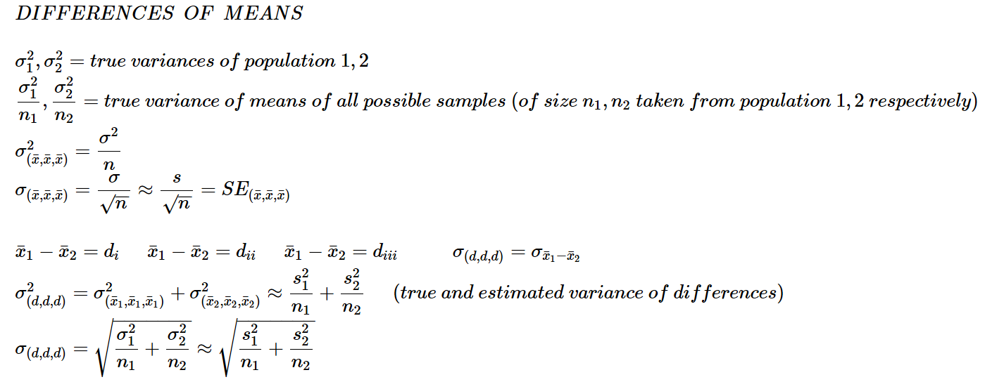

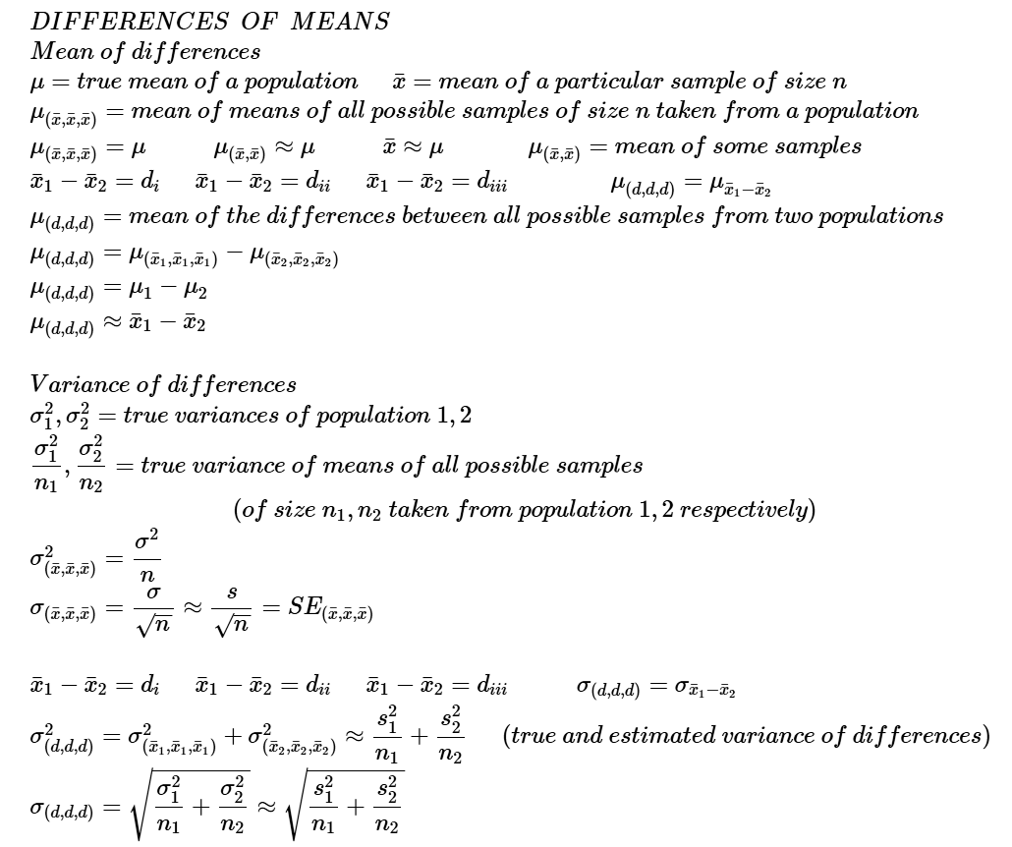

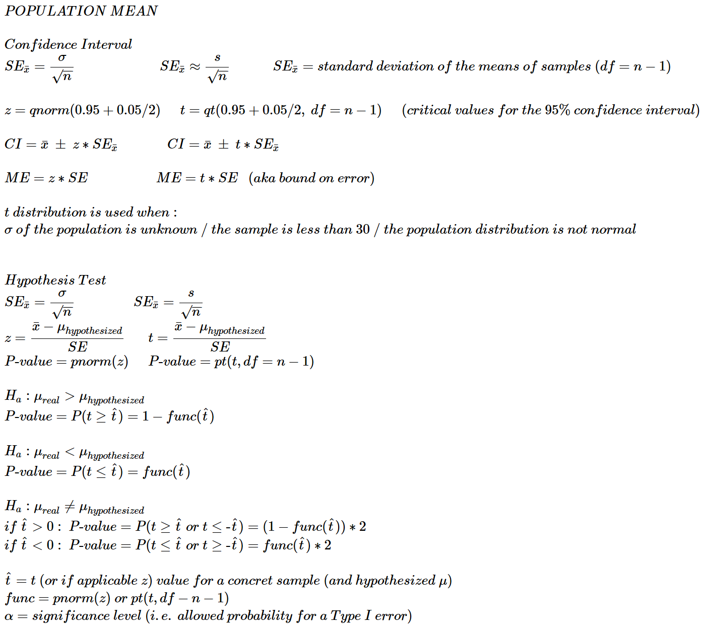

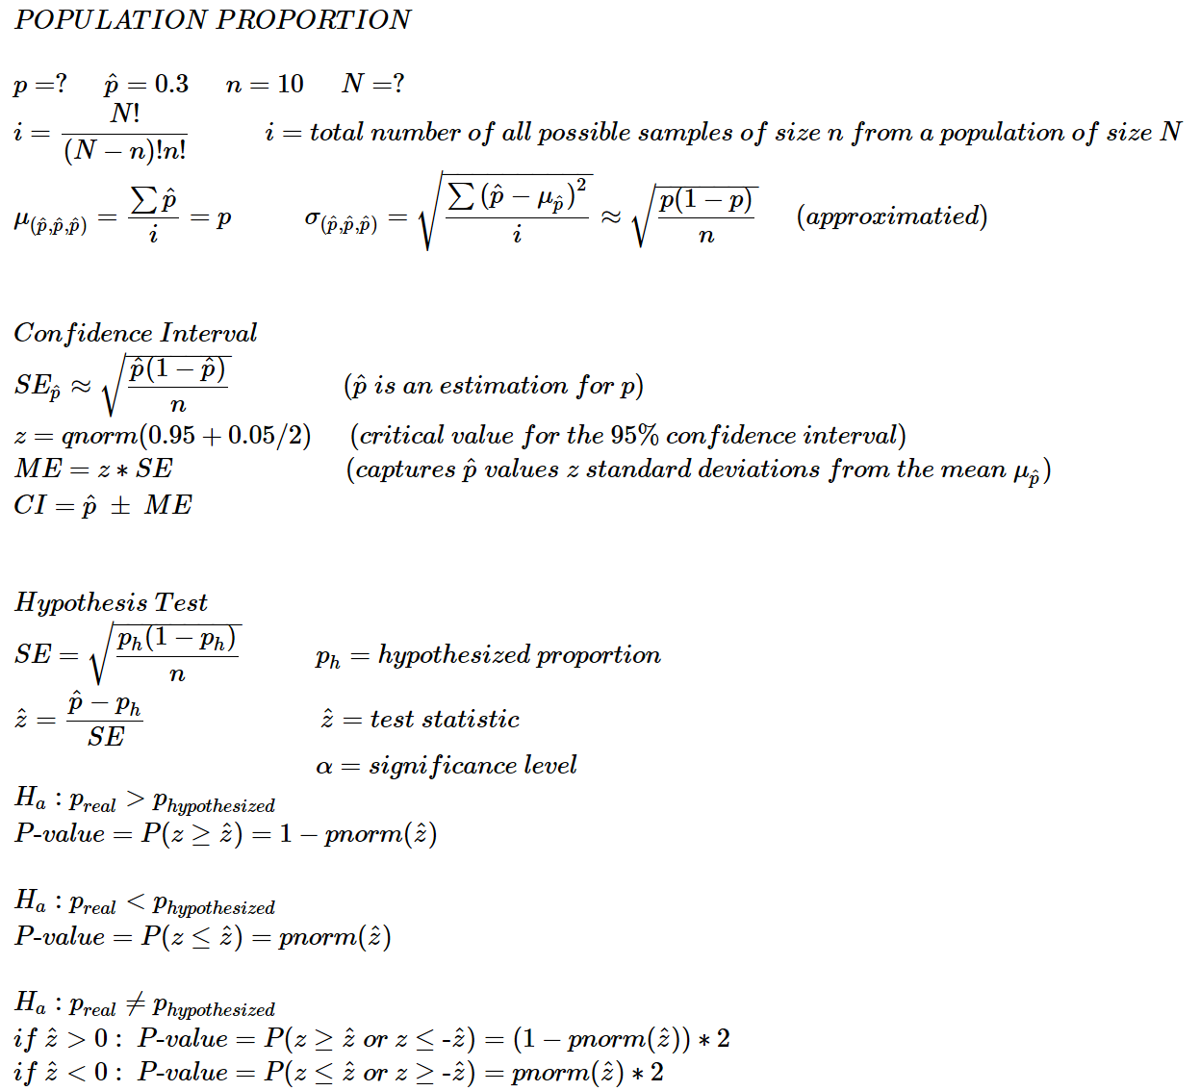

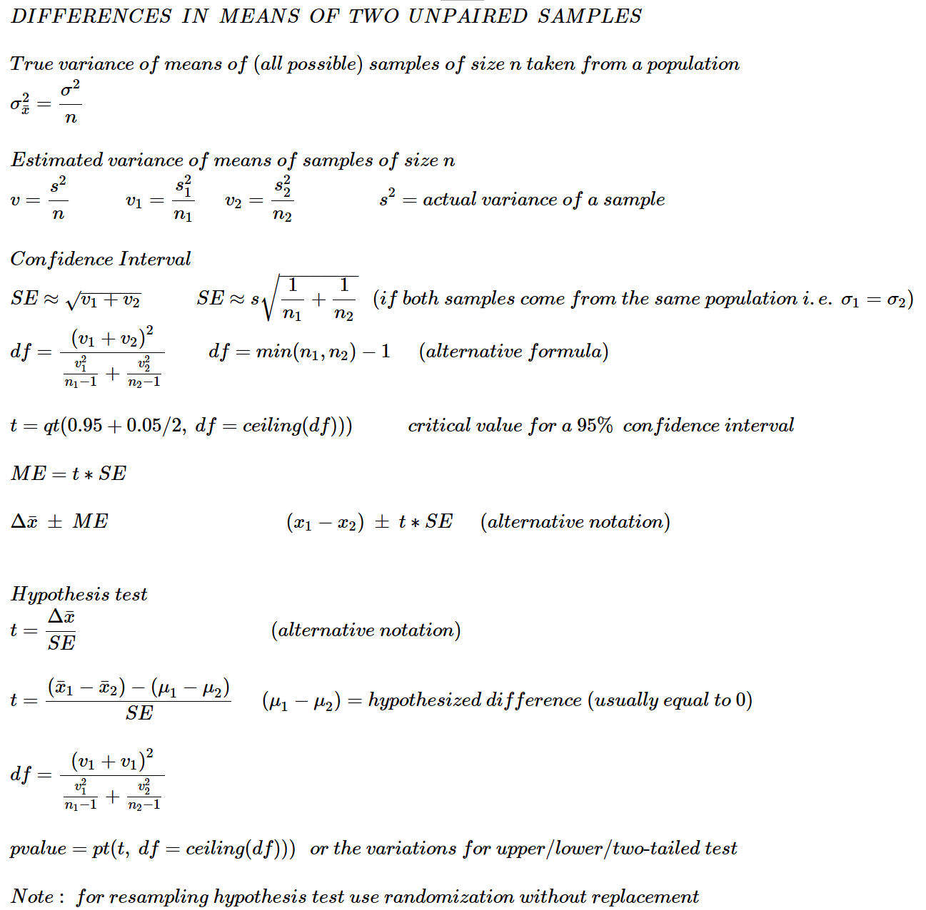

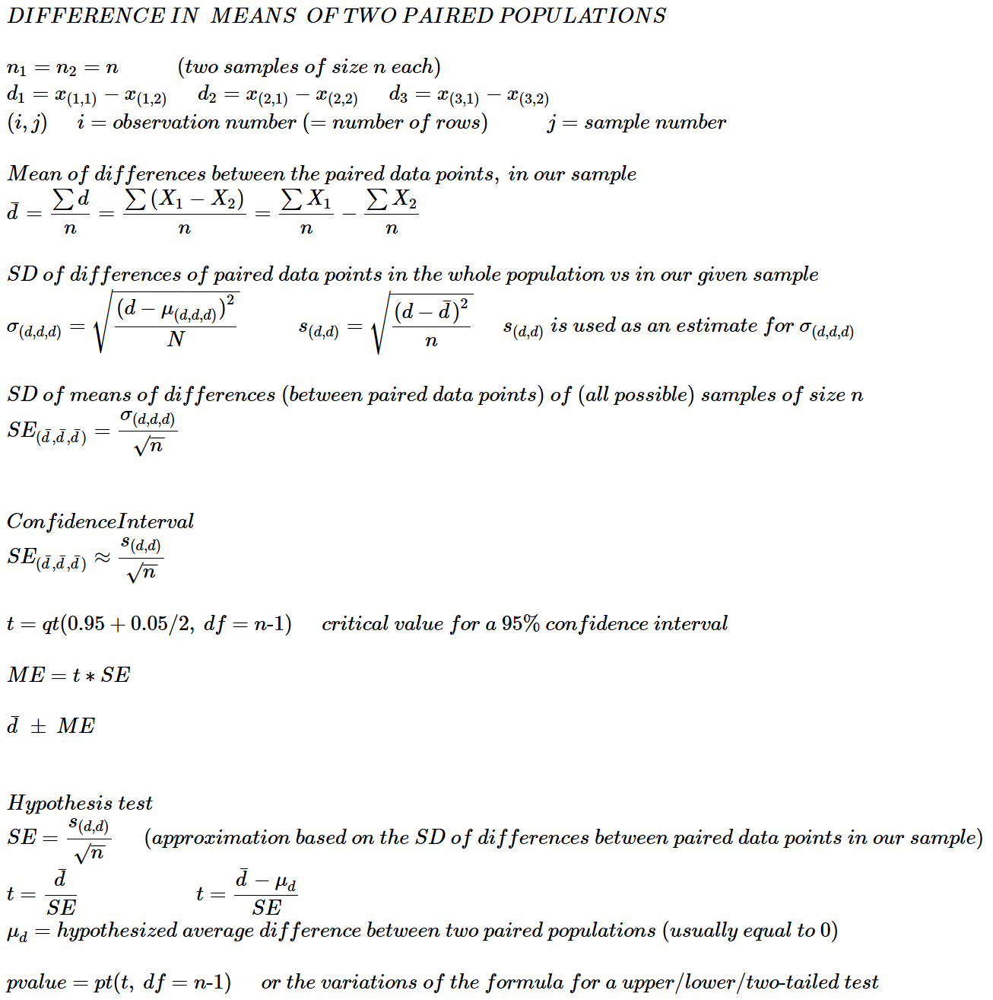

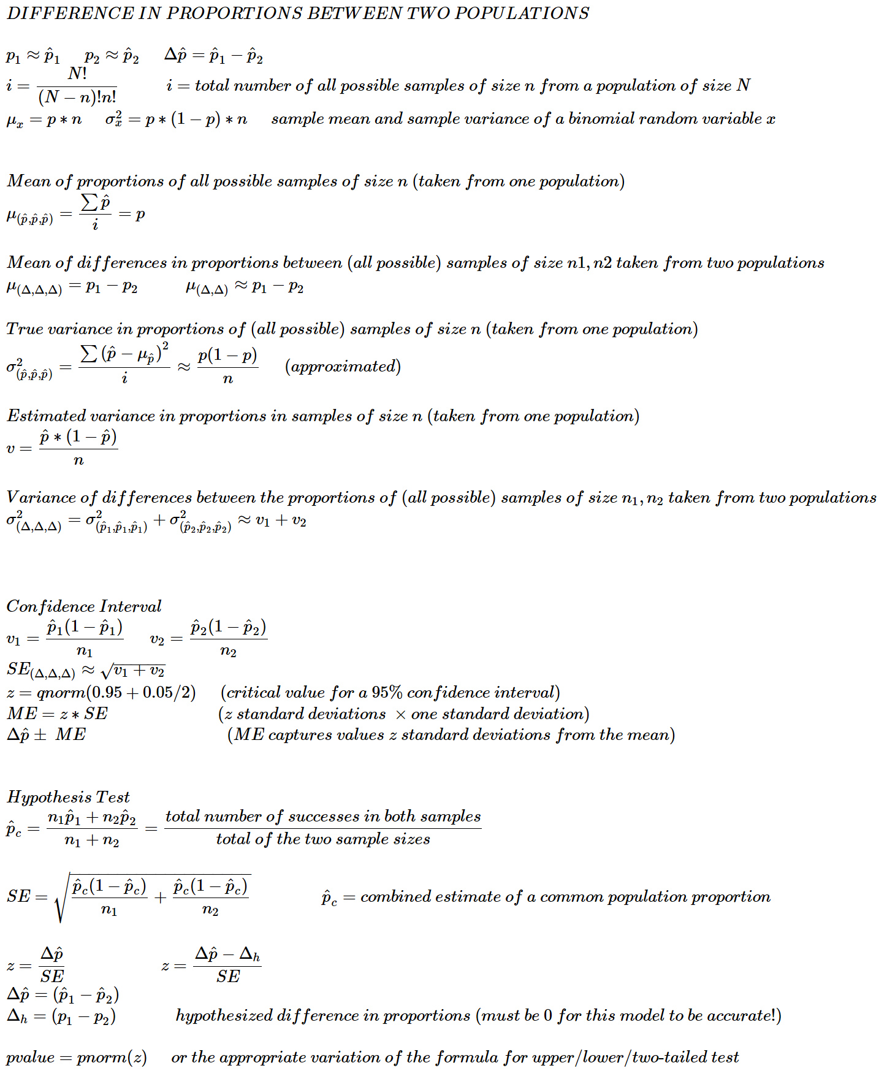

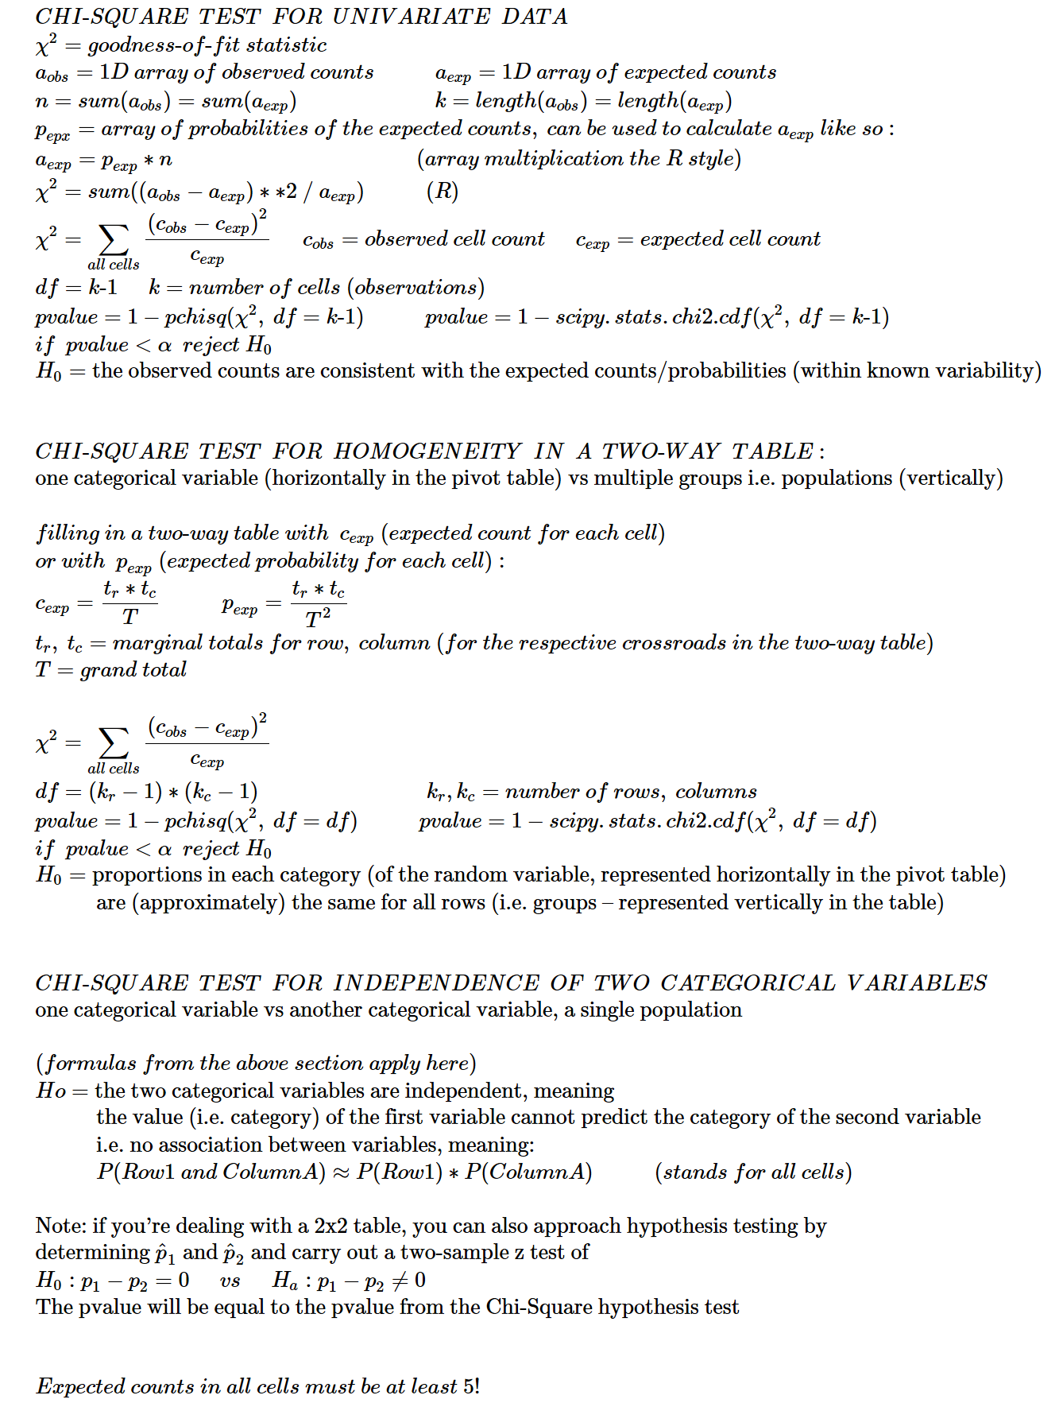

**PUTTING IT ALL TOGETHER**

We have a group of 100 people. We divide them into two subgroups: Control group with 30 people and Treatment group with 70 people. We measure the probabilities of success in each group. (success = Yes)

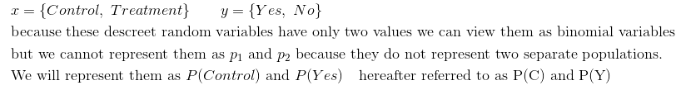

One of the questions we will ask is whether we can predict y value if we know the value of x (this would be the case if these variables were **not** independent – meaning the value of one variable is somehow dependent upon the value of the other)

|  |  |  |  |
| --- | --- | --- | --- |
|  | Yes | No | margin total |
| Control | **0.33** | **0.66** | 1 |
| Treatment | **0.43** | **0.57** | 1 |
| margin total | 0.4 | 0.6 | 1 |

Two-way table with counts and proportions Expected counts and proportions Probabilities of success in each category (subgroup)

|  |  |  |  |
| --- | --- | --- | --- |
|  | Yes | No | margin total |
| Control | **10 (0.1)** | **20 (0.2)** | 30 (0.3) |
| Treatment | **30 (0.3)** | **40 (0.4)** | 70 (0.7) |
| margin total | 40 (0.4) | 60 (0.6) | 100 |

|  |  |  |  |
| --- | --- | --- | --- |
|  | Yes | No | margin total |
| Control | **12 (0.12)** | **18 (0.18)** | 30 (0.3) |
| Treatment | **28 (0.28)** | **42 (0.42)** | 70 (0.7) |
| margin total | 40 (0.4) | 60 (0.6) | 100 |

From the **first** table we have the following information:

P(C) = 0.3 P(Y) = 0.4

P(C ∩ Y) = 0.1 *(intersection of ‘Control’ and ‘Yes’)*

P(C) * P(Y) = 0.3 * 0.4 = 0.12

P(C ∩ Y) ≠ P(C) * P(Y)

This means C and Y are **not** independent. They would be independent if their probabilities equaled the expected probabilities:

P(A ∩ B)= P(A) * P(B) 0.12 = 0.3 * 0.4 (as given in the table with expected counts and probabilities)

From the **second** table we see that the expected values maintain the same proportion from row to row:

12 : 18 = 0.666 28 : 42 = 0.666

From the **third** table we see that the probability of success in the Control group is below the expected probability of 0.4 and the probability of success in the Treatment group is above it.

**Notation:**

probability of success in the Control group = P(Y | C) = 0.33

probability of success in the Treatment group = P(Y | T) = 0.43

**Beysian Rule:**

$$P\left(Y \right| C)=\frac{P\left(C ∩Y\right)}{P(C)}=\frac{0.10}{0.30}=0.33$$

P(C ∩ Y) is a concrete cell at the intersection

P(Y | C) is the probability within a subset of the table (in this case this subset is horizontal i.e. a row)

**Probabilities tree:**

Yes P(C ∩ Y) = 0.3 * 0.33 = 0.1

Control

No P(C ∩ N) = 0.3 * 0.6 = 0.2

Yes P(T ∩ Y) = 0.7 * 0.43 = 0.3

Treatment

No P(T ∩ N) = 0.7 * 0.57 = 0.4

Total: 1

0.33

0.66

0.3

0.43

3

0.7

0.57

**Conditional probability (medical test model)**

If a randomly selected person (from our sample of 100 people or from the whole population) has had success (e.g. was healed) what is the probability that he was not treated (for that disease and just spontaneously got well)?

probability that a person was not treated given he was healed = P(C | Y)

$$P\left(C | Y\right)=\frac{P\left(C∩Y\right)}{P\left(T∩Y\right)+P\left(C∩Y\right)}=\frac{0.1}{0.3+0.1}=0.25$$

we can use the Bayesian equation and rewrite:

$$P\left(C | Y\right)=\frac{P\left(C∩Y\right)}{P\left(Y\right)}=\frac{0.1}{04}=0.25$$

after all $P\left(T∩Y\right)+P\left(C∩Y\right)=P\left(Y\right)$

If a random person is healed it’s 25% chance that he was not treated for his disease at all. This suggests that the treatment is not that effective and that there is no association between the two variables, in other words these two variables are probably independent (meaning that in real life the proportion of those healed under treatment and without it is approximately the same).

Note that the two random variables are actually **not** independent in the particular sample that we have (as we saw above). However, this means that they are probably independent in the real world, if we consider the whole population(s) the sample(s) came from.

**Chi-Square test:**

The kind of Chi-Square test that can be performed on our data is the Chi-Square test for independence of two categorical variables. In our case *x = {Control, Treatment}* and *y={Yes, No}*

To calculate chi-squared we use the table with observed counts and the table with expected counts (expected counts in each cell must be at least 5)

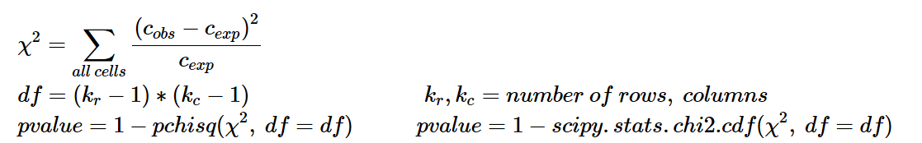

chi-squared = 0.79 df = 1 pvalue = 0.37

Contribution to chi-squared:

|  |  |  |  |
| --- | --- | --- | --- |
|  | Yes | No | margin total |
| Control | **0.33** | **0.22** | 0.56 |
| Treatment | **0.14** | **0.10** | 0.24 |
| margin total | 0.45 | 0.32 | 0.79 |

*(note that chi-squared values don’t have to be decimals less than zero)*

**null hypothesis**: *(the following statements are all equivalent)*

* the two categorical variables are **independent**
* the value (category) of the first variable cannot predict the category of the second variable
* the observed counts are very close to the expected counts
* no association between variables
* P(Row1 ∩ ColumnA)≈P(Row1)∗P(ColumnA) (stands for all cells)

Since the pvalue (the probability of null hypothesis being true) is very high, we fail to reject the null hypothesis.

If we on the other hand rejected the null hypothesis we would say that these two variables are dependent which means, we can predict the y variable from the value of x. For example, if we know that a person belongs to the Control group he would probably fall into the No category, and if he belonged to the Treatment group he would fall into the Yes category.

Furthermore, we would prefer the Treatment category because the probability of success in the Control group is below the expected probability of 0.4 and the probability of success in the Treatment group is above it.

**Two-sample hypothesis test for difference in proportions**

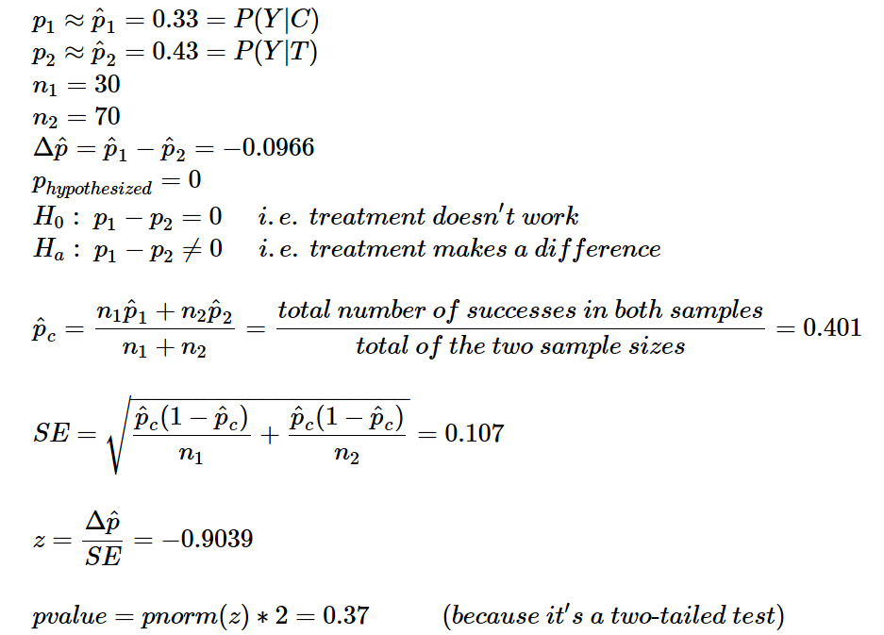

Note that the pvalue is equal to the calculated pvalue above.

**Confidence Interval for difference in proportions between two populations**

In our case population 1 = Control population 2 = Treatment

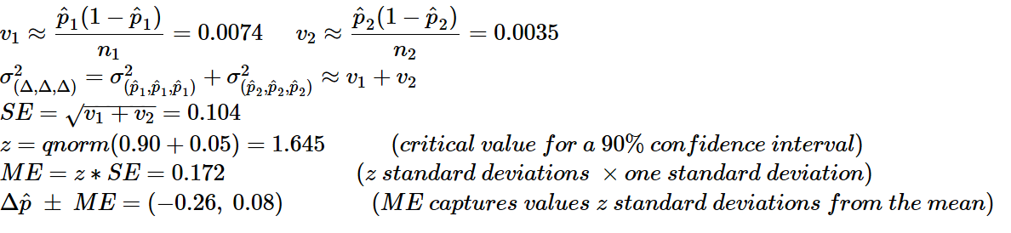

This means that in the extreme case $p_{2}$ can be 26 percentage points greater than $p_{1}$

$p_{1}$ can be up to 8 percentage points greater than $p_{2}$

Because our interval spans negative and positive values, it again suggests that there is no real difference in proportions between the two populations (Control population and Treatment population), meaning we are not convinced that the treatment is effective and that the proportion of people healed with treatment is higher than the proportion of people healed without treatment.

**Other information about our binomial random variables**

For our analysis of a binomial random variable we will use

P(Y | T) = 0.43 (probability of being healed if treated for the disease)

So our p = 0.43 (the population proportion p is of course estimated from the sample proportion p-hat)

n = 70 (we will take samples of size 70 people multiple times)

x = {0,1,2…70} (we can have 0 through 70 successes in a random sample of size 70)

Probability that you will have exactly k healed people in a random sample of 70 people (who underwent treatment of course):

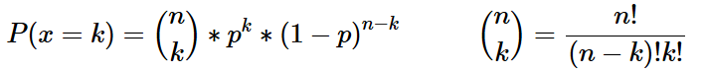

for example the probability that you will have exactly half of the people healed in a random sample of 70:

dbinom(35, size=70, prob=0.43) ≈ 0.05

the probability that you will have 50% or less of the people healed in a random sample of 70:

pbinom(35, size=70, prob=0.43) ≈ 0.90

The normal distribution can be used as an approximation to the binomial distribution:

$$z=\frac{35.5-μ}{σ}=\frac{35.5-n*p}{\sqrt{p*\left(1-p\right)*n}}=\frac{35.5-30.1}{17.2}=0.314$$

$$P=pnorm\left(z\right)=0.62$$

*(the results obviously differ, probably because the p is not close enough to 0.5)*

Mean number of healed people that you will get in samples of size 70:

$$μ_{x}=n*p=70*0.43=30.1 people$$

Standard deviation of the healed numbers in samples of 70:

$$σ_{x}=\sqrt{p*\left(1-p\right)*n}=0.43*0.57*70=17.2 people$$

Standard deviation of the actual proportions of healed people in samples of 70:



**CONTINUOUS**

$$N=population size$$

$$n=sample size$$

$$i= \left({N \atop n}\right)=number of all possible samples of size n drawn from a population of size N$$

$x_{i}=a data point from a sample, also denoted as x$

$$\overline{x}=mean of the values in a particular sample$$

|  |  |  |
| --- | --- | --- |
|  | **Whole population** | **Sample-based estimations** |
| mean and SD  **of data points** | $$μ=\frac{∑x_{i}}{N}$$ $$σ=\sqrt{\frac{∑{\left(x_{i}-μ\right)}^{2}}{N}}$$ | $\overline{x}=\frac{∑x_{i}}{n}$ $$s=\sqrt{\frac{∑{\left(x_{i}-\overline{x}\right)}^{2}}{n-1}} s^{2}=\frac{∑{\left(x_{i}-\overline{x}\right)}^{2}}{n-1}$$ |
| mean and SD  **of means of samples of size n** | $$μ_{\overline{x}}=\frac{∑\overline{x}}{i}=μ$$ $σ_{\overline{x}}=\frac{∑{\left(\overline{x}-μ\right)}^{2}}{i}=\frac{σ}{\sqrt{n}}$* | $$μ≈\overline{x}$$ $$σ_{\overline{x}}≈\frac{s}{\sqrt{n}} σ_{\overline{x}}^{2}≈\frac{s^{2}}{n}$$ |
| mean and SD  **of differences (between the means of samples of size n)** | $$μ_{d}=\frac{∑\left({\overline{x}}_{1}-{\overline{x}}_{2}\right)}{j}=μ_{1}-μ_{2}$$ $$σ_{d}=\sqrt{σ_{{\overline{x}}_{1} }^{2}+σ_{{\overline{x}}_{2} }^{2}}=\sqrt{\frac{σ_{1}^{2}}{n_{1}}+\frac{σ_{2}^{2}}{n_{2}}}$$ | $$μ_{d}≈{\overline{x}}_{1}-{\overline{x}}_{2}$$ $$σ_{d}≈\sqrt{\frac{s_{1}^{2}}{n_{1}}+\frac{s_{2}^{2}}{n_{2}}} σ_{d}^{2}≈\frac{s_{1}^{2}}{n_{1}}+\frac{s_{2}^{2}}{n_{2}}$$ |

* *This formula is exact if the population is infinite, and is approximately correct if the population is finite and no more than 10% of the population is included in the sample*

**PAIRED**

$$n_{1}=n_{2}=n$$

$$X_{1},X_{2}=two samples with paired data pints$$

$$d,d,d=differences between paired data points$$

$$\overline{d}=mean of differences between paired data points from two samples$$

|  |  |  |
| --- | --- | --- |
|  | **Whole population** | **Sample-based estimations** |
| mean and SD  **of differences between pairs of data points** | $$μ_{d}=\frac{∑X_{1}-X_{2}}{N}$$ $$σ_{d}=\sqrt{\frac{∑{\left(d-μ_{d}\right)}^{2}}{N}}$$ | $$\overline{d}=\frac{∑d_{i}}{n}=\frac{∑{(X}_{1}-X_{2})}{n}=\frac{∑X_{1}}{n}-\frac{∑X_{2}}{n}$$ $$s_{d}=\sqrt{\frac{∑{\left(d-\overline{d}\right)}^{2}}{n-1}}$$ |
| mean and SD  **of means of differences**  **between pairs of data points**  **taken from two populations**  **in form of samples of size n each** | $$μ_{\overline{d}}=μ_{d}$$ $$σ_{\overline{d}}=\frac{σ_{d}}{\sqrt{n}} σ_{\overline{d}}^{2}=\frac{σ_{d}^{2}}{n}$$ | $$μ_{d}≈\overline{d}$$ $$σ_{\overline{d}}≈\frac{s_{d}}{\sqrt{n}} σ_{\overline{d}}^{2}≈\frac{s_{d}^{2}}{n}$$ |

**BINOMIAL**

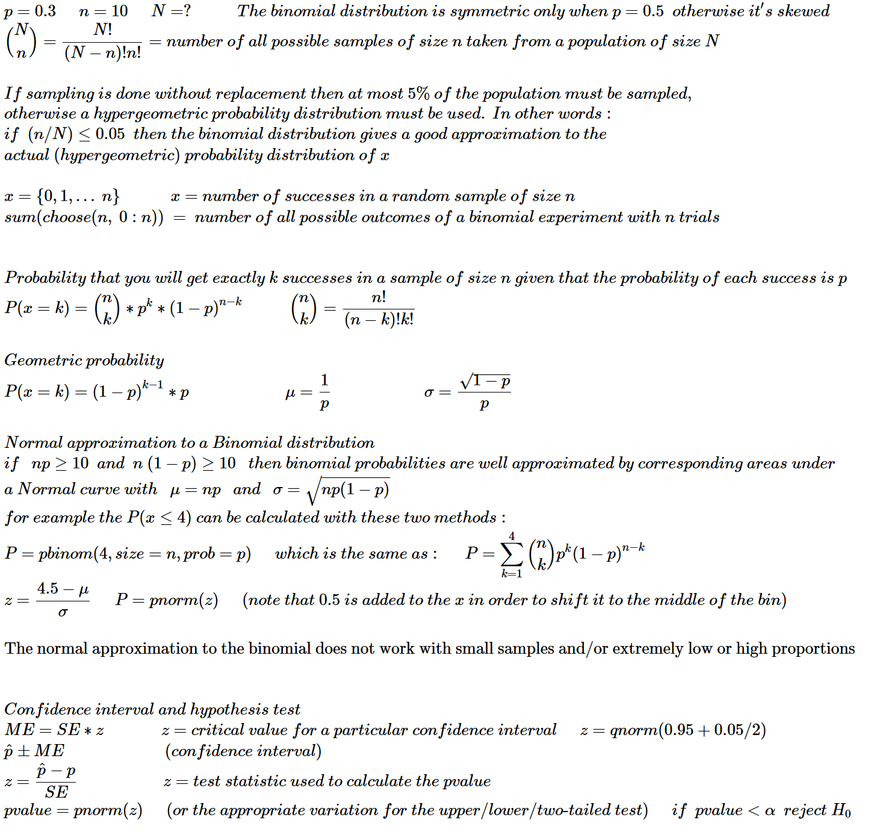

|  |  |  |
| --- | --- | --- |
| *binomial*  *(continued)* | **Whole population** | **Sample-based estimations** |
| proportion and SD  **of data points** | $$μ=p$$ $$σ=\sqrt{p\left(1-p\right)}$$ | $$p≈\hat{p}$$ $$σ≈\sqrt{\hat{p}\left(1-\hat{p}\right)}$$ |
| mean and SD  **of** proportions **of samples of size n** | $$μ_{\hat{p}}=\frac{∑\hat{p}}{i}=p$$ $$σ_{\hat{p}}=\frac{\sqrt{∑{\left(\hat{p}-p\right)}^{2}}}{i}≈\sqrt{\frac{p\left(1-p\right)}{n}}$$ | $$μ_{\hat{p}}≈\hat{p}≈p$$ $$σ_{\hat{p}}≈\sqrt{\frac{\hat{p}\left(1-\hat{p}\right)}{n}}$$ |
| mean and SD  **of the number of successes in samples of size n** | $μ_{x}=n*p=\sum{\left({n \atop k}\right)*p^{k}*{\left(1-p\right)}^{n-k}*k}$ $$σ_{x}=\sqrt{p\left(1-p\right)n}$$ | $$μ_{x}≈n*\hat{p}$$ $$σ_{x}≈\sqrt{\hat{p}*\left(1-\hat{p}\right)*n}$$ |
| mean and SD  **of differences between the proportions of samples of size n** | $$μ_{d}=\frac{∑\left({\hat{p}}_{1}-{\hat{p}}_{2}\right)}{i}=p_{1}-p_{2}$$ $$σ_{d}=\sqrt{\frac{∑{\left(\left({\hat{p}}_{1}-{\hat{p}}_{2}\right)-\left(p_{1}-p_{2}\right)\right)}^{2}}{i}}=$$ $$=\sqrt{\frac{∑{\left({\hat{p}}_{1}-p_{1}\right)}^{2}}{i_{1}}+\frac{∑{\left({\hat{p}}_{2}-p_{2}\right)}^{2}}{i_{2}}}=$$ $$=\sqrt{σ_{1}^{2}+σ_{2}^{2}}≈\sqrt{\frac{p_{1}\left(1-p_{1}\right)}{n_{1}}+\frac{p_{2}\left(1-p_{2}\right)}{n_{2}}}$$ | $$μ_{d}≈{\hat{p}}_{1}-{\hat{p}}_{2}$$ $$σ_{d}≈\sqrt{\frac{{\hat{p}}_{1}\left(1-{\hat{p}}_{1}\right)}{n_{1}}+\frac{{\hat{p}}_{2}\left(1-{\hat{p}}_{2}\right)}{n_{2}}}$$ |

**DISCREET**

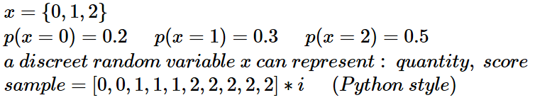

|  |  |  |
| --- | --- | --- |
|  | **Whole population** | **Sample-based estimations** |
| mean and SD  **of data points** | $$μ_{x}=∑x*p\left(x\right)$$ $$σ_{x}=\sqrt{∑{\left(x-μ_{x}\right)}^{2}*p(x)}$$ | $$\overline{x}=mean\left(sample\right)$$ $$s=sd\left(sample\right)$$ |
| mean and SD  **of means of samples of size n** | $$μ_{\overline{x}}=μ_{x}=\frac{∑\overline{x}}{i}$$ $$σ_{\overline{x}}=\sqrt{\frac{∑{\left(\overline{x}-μ_{x}\right)}^{2}}{i}}$$ |  |

**UNIVARIATE LINEAR REGRESSION**

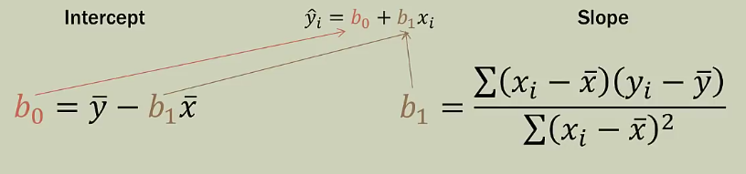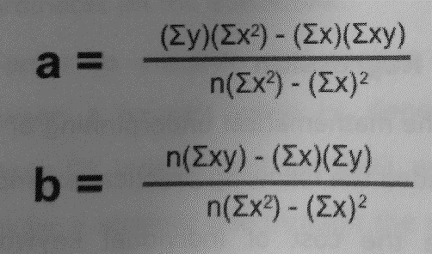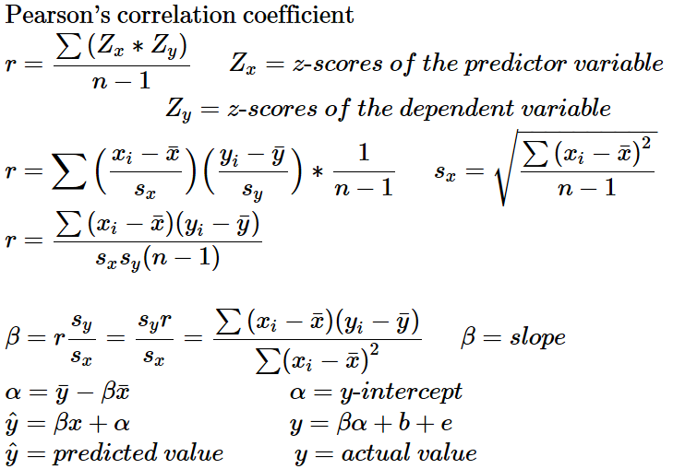

a = intercept

b = slope

Consider using the least-squares line to predict the value of y associated with an x value some specified number of standard deviations away from $\overline{x}$. Then the predicted y value will be only r times this number of standard deviations from $\overline{y}$

$z=\frac{x-\overline{x}}{s_{x}}$ $\hat{y}=z*\overline{y}*r$ $\hat{y}=\frac{x-\overline{x}}{s_{x}}*\overline{y}*r$

The regression line of y on x should not be used to predict x, because it is not the line that minimizes the sum of squared deviations in the x direction.

**Difference between an outlier and an influential observation:**

**Influential observation:** An observation is potentially influential if it has an x value that is far away from the rest of the data (separated from the rest of the data in the x direction). to determine if the observation is in fact influential, we  
assess whether removal of this observation has a large impact on the value of the slope or intercept of the least-squares line.

**Outlier:** An observation that has a large residual. outlier observations fall far away from the least-squares line in the y direction

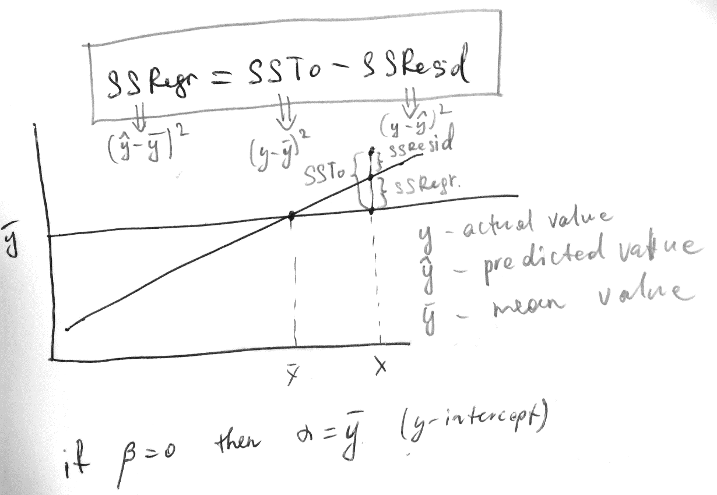

**Coefficient of determination**

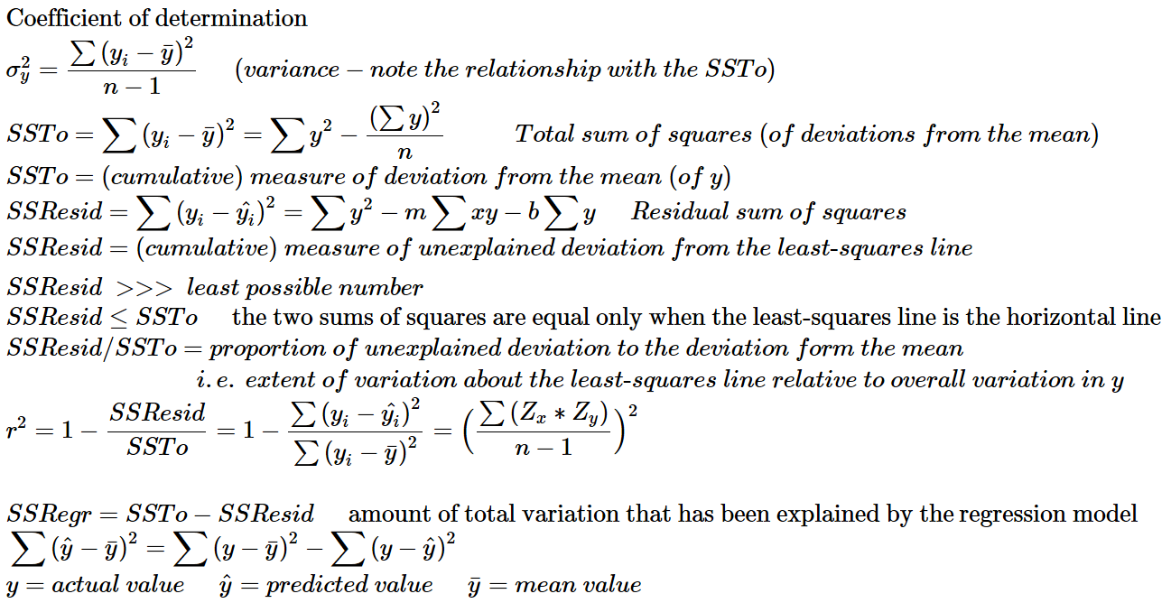

Coefficient of determination is the proportion of the variability in the dependent variable that is predictable from the independent variable.

**Standard Deviation of Residuals (aka Standard Error of Estimate)**

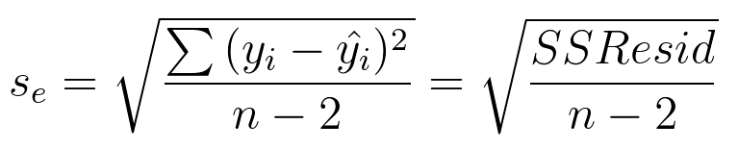

Roughly speaking, $s_{e}$ is the typical amount by which an observation deviates from the least-squares line,

in other words, the value of $s_{e}$ tells us that if the least-squares regression line is used to predict a y-value, a typical difference between the predicted value and the actual value would be about $s_{e}$ units (cm, dollars, pieces etc)

Note:

**coefficient of determination** explains the deviation in proportional terms (i.e. in %), while

**SD about the least-squares line** explains the deviation in absolute terms (i.e. if we’re dealing with height, it says that the typical deviation from the regression line is x centimeters)

As a rule the greater $r^{2}$ the smaller $s_{e}$

We decide whether the least-squares regression line is useful based the residual plot, $s_{e}$ and $r^{2}$

$s_{e}$ is a point estimate for the population standard deviation of errors $σ_{e}$

**Inference about the Slope of the Regression Line** (advanced stuff)

*b* (slope of the regression line based on a particular sample) is a point estimate for $β$ the true slope

Confidence Interval for $β$

Hypothesis Test for $β=0$ p. 675 (p.587)

Examination of the residuals: standardized residual plot

*(see next page)*

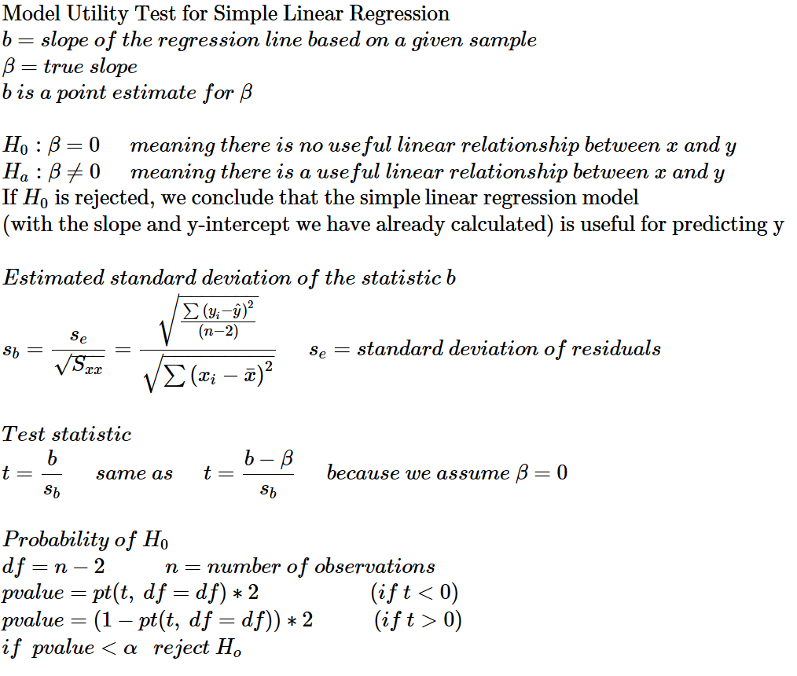

**MULTIVARIATE LINEAR REGRESSION**

**Coefficient of multiple** **determination**

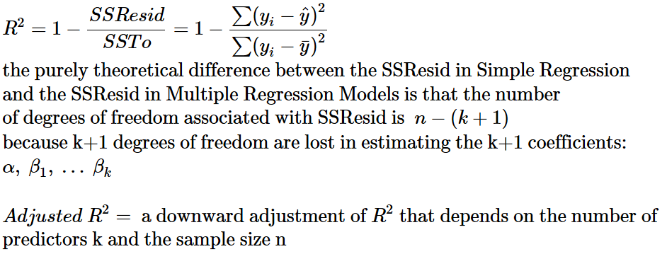

**Model Utility F Test for multiple regression**

The model utility test in simple linear regression was based on a test statistic that has a t distribution when $H_{0}: β=0$ is true. The model utility test for multiple regression is based on a test statistic that has a probability distribution called an F distribution.

We prefer a larger SSRegr relative to a smaller SSResid

The relationship of SSRegr to SSResid (adjusted with corresponding degrees of freedom*) is described by F.

So we prefer a larger F.

An F-statistic is like a z-score in a normal distribution. So a larger F would lie farther to the right in an F-distribution, meaning that the area under the curve (to the right) is small. This area under the curve (from an F value to the right) is the pvalue, i.e. the probability of the null hypothesis, which (the null hypothesis) suggests that the true regression line must be a horizontal line $y=\overline{y}=α$ with all coefficients equal to 0 ( $β_{1}=β_{2}=β_{k}=0$), because it is supposedly useless to try to find an appropriate regression line.

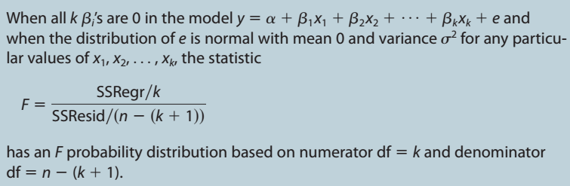

$$k=number of predictors \left(i.e. the model has k+1 dimensions\right)$$

$$n=number of observations i.e. data points$$

|  |  |  |
| --- | --- | --- |
| **x1** | **x2** | **y** |
| 12 | 1.7 | 120 |
| 14 | 3.2 | 130 |

Note that if we have the following data:

and use the following model: $\hat{y}=α+β_{1}x_{1}+β_{2}x_{2}+β_{3}x_{3}+β_{4}x_{4}+β_{5}x_{5} where x_{3}=x_{1}^{2}, { x}_{4}=x_{2}^{2}, x_{5}=x_{1}x_{2}$

then k = 5, and not 2 !!!

* degrees of freedom

df1 = k

df2 = n-(k+1)

note that degrees of freedom are used twice: once in the formula for the F statistic

and once when pvalue (i.e. the area under an F distribution curve) is calculated:

$$F=\frac{SSRegr / df_{1}}{SSResid / df_{2}}$$

pvalue = 1 - pf(F, df1=k, df2=n-(k+1))

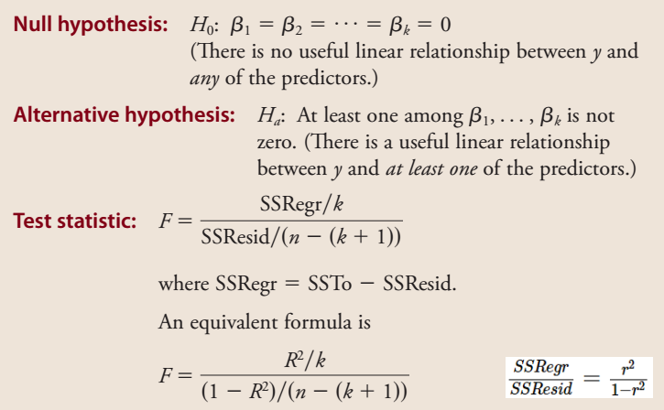

**More on F and p for Multiple Regression**

F and therefore p are the measures of model utility.

Conceptual similarity between R2 and F:

n = number of data-points

k = number of predictors

SSR = sum of squared (explained) regressions (i.e. predicted by the line)

SSE = sum of squared errors / residuals

SST = sum of squared total deviations from the mean line

**F** value is comparable to odds = $\frac{p}{1-p}$

$$F\sim \frac{SSR}{SSE}\sim \frac{SSR/n}{SST/n}\sim \frac{Var_{explained}}{Var_{unexplained}}$$

$$F=\frac{SSR/df_{1}}{SSE/df_{2}}=\frac{SSR/k}{SSE/(n-(k+1))}=\frac{R^{2}/k}{(R^{2})/(n-(k+1))}$$

$$df_{1}=k=number of predictors/features$$

$$df_{2}=n-(k+1)$$

if $F=\frac{large number}{small number}=very large number$ meaning this large number will be located at the far right end of the F-curve, whereas smaller numbers will be located at the lower/left tail of the curve.

Small numbers are numerous and large numbers are rare, that’s why the F curve tapers to the right. We measure the probability of our large number or even larger numbers by figuring out the area under the F-curve from our large number to the right end. This area will be of course a small portion of the curve (since our number is large):

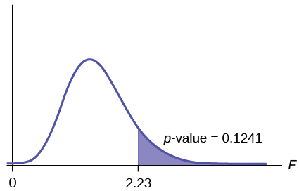

That area under the curve is the p-value which is calculated as follows:

**p <- 1 - pf(F, df1 = k, df2 = n-(k+1))**

**p <- pf(F, df1, df2, lower.tail = FALSE)**

p = probability of our (large) F value or even larger F values if null hypothesis is true

So, we need a large R2 and a small p for our model to be of any use. If the p-value is small (<0.05) then we reject the null hypothesis and come to a conclusion that our model is useful.

**ANOVA**

**factor** is what influences the change between the groups (aka levels, populations) compared.

if $H_{0}$ is true then the factor has no influence, i.e. is not causing any change in real life populations, so the observed differences in means between the groups (aka levels) is misleading.

Here is a summary of the **single-factor analysis of variance**, but more advanced techniques can do ANOVA on samples on which more than one factor has influence.

$$k=number of groups, aka levels, treatments, populations being compared$$

$$H_{0}: μ_{1}=μ_{2}=…=μ_{k}$$

$$H_{a}:at least two of the μ^{'}s are different$$

The question that ANOVA asks is: are the $μ's$ really different or is the seeming difference in the ${\overline{x}}^{'}s$ is caused by the variability within the populations (which caused the $\overline{x}'s$  to be different). In other words: if the differences between $\overline{x}'s$ can be explained by the variabilities within the populations (estimated from the variances of samples of course) then we cannot reject $H_{0}$

**Notation**

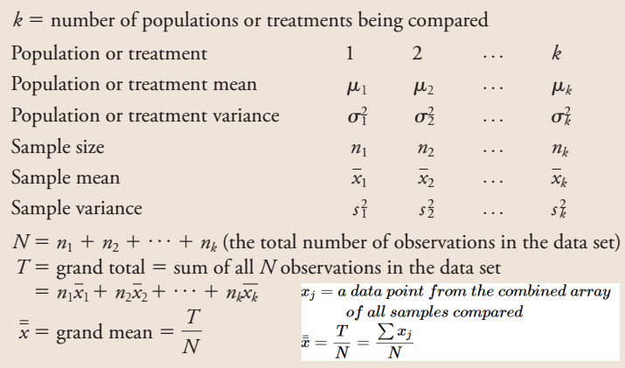

**Calculation of SSW, SSB**

$$SSW=sum of squares within \left(the groups\right)$$

$$SSB=sum of squares between (the groups)$$

$$SST=total sum of squares$$

$\overline{\overline{x}}=\frac{x_{i}+…+x_{N}}{N}=mean(all values)$ $\overline{\overline{x}}≠\frac{{\overline{x}}_{1}+…+{\overline{x}}_{k}}{k}$

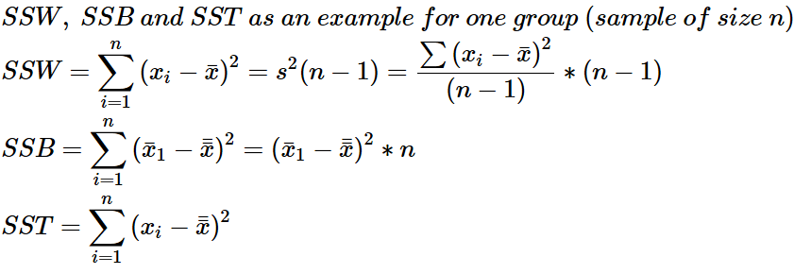

**Hypothesis test**

$$H_{0}: μ_{1}=μ_{2}=…=μ_{k}$$

$$H_{a}:at least two of the μ^{'}s are different$$

What you will need (for each group): $data points or grand total, n, \overline{x}, \overline{\overline{x}}, s^{2}$

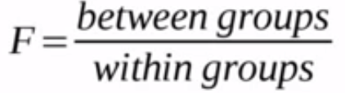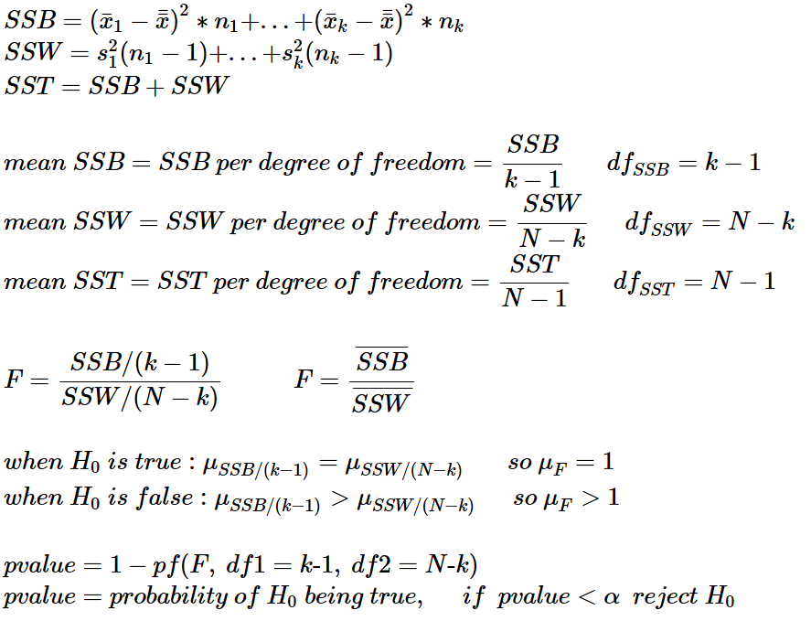

**Alternative nomenclature:**

*SSB = Treatment (sum of squares), SSC = sum of squares between the columns (which represent treatments/groups)*

*SSW = Error (sum of squares), SSE = sum of squares of error*

**We need these conditions to be fulfilled:**

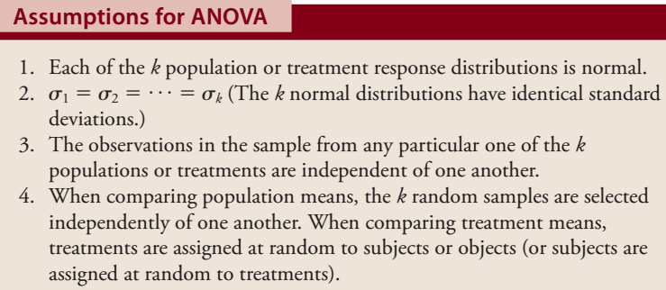

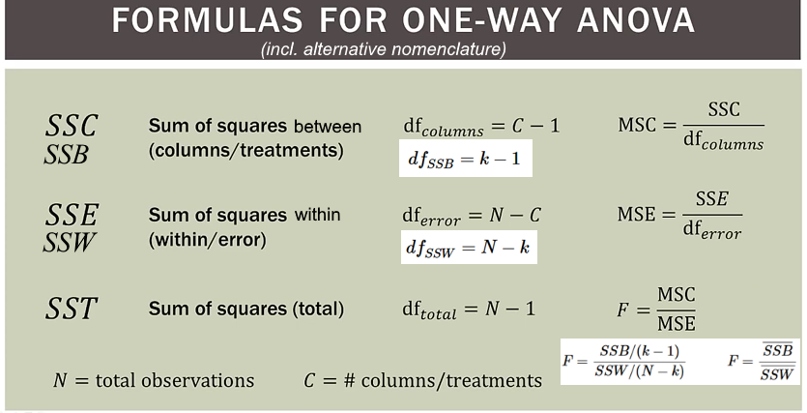

**Example**

We take three samples (in this case all of different sizes) from three populations

The largest standard deviation must be at most 1.5 times larger than the smallest standard deviation.

In our example the smallest SD = 10

the largest = 28.6

|  |  |  |  |
| --- | --- | --- | --- |
|  | **Sample 1** | **Sample 2** | **Sample 3** |
|  | 10 | 40 | 50 |
|  | 20 | 60 | 70 |
|  | 30 | 80 | 90 |
|  |  | 100 | 110 |
|  |  |  | 120 |
| *n* | 3 | 4 | 5 |
| $$\overline{x}$$ | 20 | 70 | 88 |
| *s* | 10 | 25.8 | 28.6 |
| $$s^{2}$$ | 100 | 666.7 | 820 |

**Dot-plot of the samples’ data points and their means**

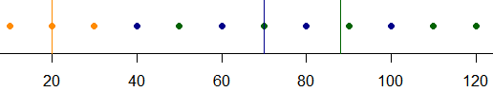

**Boxplots**

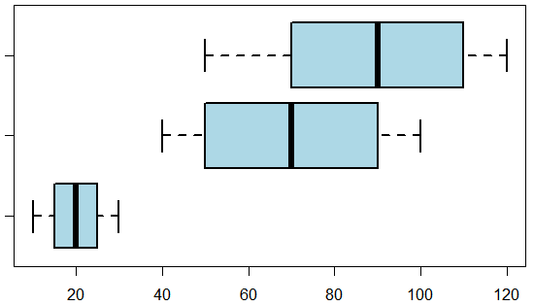

**Normal Probability Plot**

We can build QQ-plots for each sample but because our samples are small we build a combined qq plot. First we subtract the means from the data points of each respective sample, and then just pool all the values together. The sorted combined array will look like this: -38 -30 -18 -10 -10 0 2 10 10 22 30 32

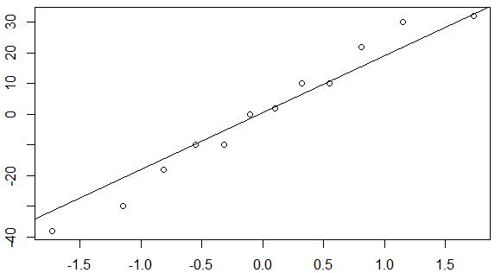

**Calculate the P-Value**

note that mean(c(a1,a2,a3)) ≠ mean(c(mean(a1), mean(a3), mean(a3)))

$\overline{\overline{x}}=\frac{x_{i}+…+x_{N}}{N}=mean(all values)$ $\overline{\overline{x}}≠\frac{{\overline{x}}_{1}+…+{\overline{x}}_{k}}{k}$

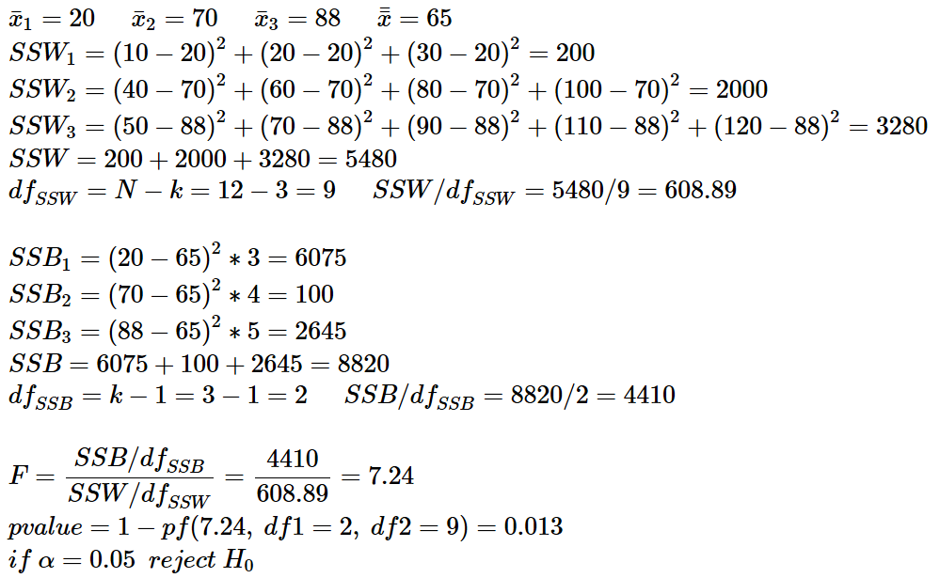

Rejecting $H_{0}$ we proclaim that we cannot support the claim that the $μ's$ of our three samples are all the same.

**Summary table**

|  |  |  |  |  |
| --- | --- | --- | --- | --- |
| **source of variation** | **df** | **sum of squares** | **mean square** | **F** |
| **Treatments (SSB)** | 2 | 8820 | 4410 | 7.24 |
| **Error (SSW)** | 9 | 5480 | 608.89 |  |
| **Total (SST)** | 11 | 14300 |  |  |

P-Value = 0.013

**Multiple comparisons procedure (Tukey-Kramer) (p. 746)**

From the boxplots we see that the mean of sample 1 is definitely different from the means of the other two samples. Can we test the hypothesis that the means of sample 2 and sample 3 are equal?

**Hypothesis test for difference in means of two unpaired populations**

*here sample 2 = sample 1 sample 2 = sample3*

$$H_{0}: μ_{1}=μ_{2} H_{a}: μ_{1}≠μ_{2}$$

$$means: {\overline{x}}_{1}=70 {\overline{x}}_{2}=88 Δ\overline{x}=-18$$

$$variance of values within samples: s_{1}^{2}=666.7 s_{2}^{2}=820$$

$$estimated variance of means of samples of size n: v=\frac{s^{2}}{n} v_{1}=\frac{666.7}{4}= 166.7 v_{2}=\frac{820}{5}=164$$

$$estimated standard deviation of means of differences in means of two unpaired samples: SE=\sqrt{v_{1}+v_{2}}=\sqrt{166.7+164}=18.2$$

$$t statistic=\frac{Δ\overline{x}}{SE}=-\frac{18}{18.2}=-0.98987$$

$$df=7$$

$$pvalue=pt\left(t, df=7\right)=0.36$$

The probability that the true means of the two populations are equal is 36%

**BAYES’ PROBABILITIES**

|  |  |  |  |
| --- | --- | --- | --- |
|  | Yes (**B**) | No | margin totals |
| Control (**A**) | **0.1** | **0.3** | 0.4 |
| Treatment | **0.2** | **0.4** | 0.6 |
| margin totals | 0.3 | 0.7 | 1 |

P(A) marginal or unconditional probability

P(A|B) conditional probability (probability of a cell in the table’s column or row subset)

P(A⋂B) a particular cell in the table, intersection in a Venn diagram

**Probability of the union**

$P\left(A⋃B\right)=P\left(A\right)+P\left(B\right) if A and B are mutually exlusive, i.e. if P\left(A⋂B\right)=0$

analogy: A=1 on a die B=6 on a die

$$P\left(A⋃B\right)=P\left(A\right)+P\left(B\right)-P\left(A⋂B\right) if A and B are not mutually exlusive, i.e. P\left(A⋂B\right)>0$$

analogy: if A=Control, and B=Yes then P(A⋃B) is the probability that a randomly chosen patient either belongs to the Control group or has been heeled (Yes) (but not both):

P(Control OR Yes) = 0.4 + 0.3 – 0.1 = 0.6

Control

0.3

Yes

0.2

0.1

**Probability of the intersection, multiplication law**

$$P\left(A⋂B\right)=P\left(A\right)*P\left(B\right) if independent$$

analogy: coin tosses (0.5*0.5=0.25)

$$P\left(A⋂B\right)=P\left(A\right)*P\left(B | A\right) if dependent$$

analogy: table (see above);

two draws from a bag of marbles (because the second draw is dependent upon the result from the first draw: 1/10 * 1/9)

cell

$$P\left(B | A\right)=\frac{P\left(A⋂B\right)}{P\left(A\right)}$$

margin total

cell in a table’s subset

$$event A and event B are independent ⇔P\left(B\right)=P(B|A)$$

**Bayes' theorem**

|  |  |  |  |
| --- | --- | --- | --- |
|  | B |  |  |
| A |  |  |  |
| C |  |  |  |
|  |  |  |  |

$$P\left(A | B\right)=\frac{P\left(A⋂B\right)}{P\left(B\right)}$$

$$because P\left(A⋂B\right)=P\left(A\right)*P\left(B | A\right) we rewrite:$$

$$P\left(A | B\right)=\frac{P\left(A\right)*P\left(B | A\right)}{P\left(B\right)}$$

$$because P\left(B\right)=P\left(A⋂B\right)+P\left(C⋂B\right) we can rewrite:$$

$$P\left(A | B\right)=\frac{P\left(A\right)*P\left(B | A\right)}{P\left(A⋂B\right)+P\left(C⋂B\right)}$$

$$because P\left(A⋂B\right)=P\left(A\right)*P\left(B | A\right) we can rewrite:$$

$$P\left(A | B\right)=\frac{P\left(A\right)*P\left(B | A\right)}{P\left(A\right)*P\left(B | A\right)+P\left(C\right)*P(B|C)}$$

$$P\left(C⋂B\right)=P(\overline{A})*P(B|\overline{A})$$

*so we can rewrite:*

$$P\left(A | B\right)=\frac{P\left(A\right)*P\left(B | A\right)}{P\left(A\right)*P\left(B | A\right)+P(\overline{A})*P(B|\overline{A})}$$

**Medical test**

Suppose we have two samples each of size 100. One of them (Yes) is contaminated for our test to test it, and the other one (No) is disease free:

|  |  |  |
| --- | --- | --- |
| supertest  our test | **Yes** | **No** |
| **Positive** | 0.9 | 0.05 |
| **Negative** | 0.1 | 0.95 |
|  |  |  |

***Counts Probabilities (conditional!) i.e. likelihoods***

|  |  |  |
| --- | --- | --- |
| supertest  our test | **Yes** | **No** |
| **Positive** | 90 | 5 |
| **Negative** | 10 | 95 |
|  | **100** | **100** |

|  |  |  |
| --- | --- | --- |
| supertest  our test | **Yes** | **No** |
| **Positive** | true positive | false positive |
| **Negative** | false negative | true negative |

$$sensitivity of the test=\frac{90}{100}=P(Positive|Yes)$$

*P(Yes)* in our testing situation is 100/200=0.5 but we are interested in the prevalence of the disease in real life. Suppose *P(Yes)* in real life is 4.5% i.e. the probability that a random person has the disease is 0.045

We are interested in P(Yes|Positive) i.e. the probability of a person actually having the disease if he is tested positive.

$$P\left(Yes | Positive\right)=\frac{P\left(Yes⋂Positive\right)}{P\left(Positive\right)}$$

$$because P\left(Yes⋂Positive\right)=P\left(Yes\right)*P\left(Positive | Yes\right) and$$

$$P\left(Positive\right)=P\left(Yes⋂Positive\right)+P\left(No⋂Positive\right) we can rewrite:$$

$$P\left(Yes | Positive\right)=\frac{P\left(Yes⋂Positive\right)}{P\left(Positive\right)}=\frac{P\left(Yes\right)*P\left(Positive | Yes\right)}{P\left(Yes\right)*P\left(Positive | Yes\right)+P(No⋂Positive)}$$

$$P\left(No⋂Positive\right)=P\left(\overline{Yes}\right)*P(Positive|\overline{Yes})$$

*so we can rewrite:*

$$P\left(Yes | Positive\right)=\frac{P\left(Yes\right)*P\left(Positive | Yes\right)}{P\left(Yes\right)*P\left(Positive | Yes\right)+P\left(\overline{Yes}\right)*P(Positive|\overline{Yes})}$$

$P\left(\overline{Yes}\right)=1-0.045=0.955$ because $P\left(A\right)+P\left(\overline{A}\right)=1$

$$P\left(Positive | \overline{Yes}\right)=P\left(Positive | No\right)=0.05 (because there^{'}sonly one column besides the Yes column)$$

$$P\left(Positive | Yes\right)=0.9$$

$$P\left(Yes | Positive\right)=\frac{0.045*0.9}{0.045*0.9+0.955*0.05}=0.46=46\%$$

You get the same result with the Tree method

“Yes”, ”No” and “A” (in the examples above) are mutually exclusive **states of nature**

“Positive”, “Negative” and “B” are mutually exclusive **observable events**

P(A) and P(Yes) are **prior probabilities**

P(A|B) and P(Yes|Positive) are **posterior probabilities**

P(B|A) and P(Positive|Yes) are **likelihoods**

Summary:

**P(A) P(H) prior probability / proposition (a state of nature)** probability of having disease

**P(B) P(E) marginal probability / evidence (an observable event)** probability of being tested positive

**P(B|A) P(E|H) likelihood = sensitivity** being tested positive if infected???

**P(A|B) P(H|E) posterior probability** prob. of being infected if tested positive

P(H) / P(H’) odds

(P(H) / P(H’)) / (P(E) / P(E’)) odds ratio???

A = proposition/hypothesis = prior = state of nature = H disease

B = evidence = marginal = observable event = E tested positive or negative

|  |  |  |  |  |
| --- | --- | --- | --- | --- |
|  | | **Exposure aka Evidence, Test, Symptoms ?** | |  |
| **Treatment/Intervention**  **Group** | **Control**  **Group** | **total** |
| **Hypothesis** | **disease** | **40** | **20** | 60 |
| **no disease** | **10** | **30** | 40 |
|  | **marginal** | 50 | 50 | 100 |

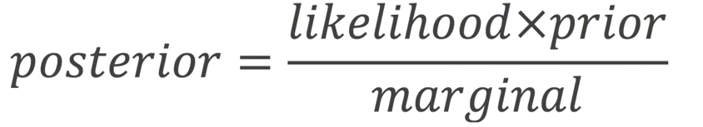

P(data | distribution) what’s the probability of this particular value given this distribution?

L(distribution | data) what’s the likelihood that the value we observe belongs to this distribution?

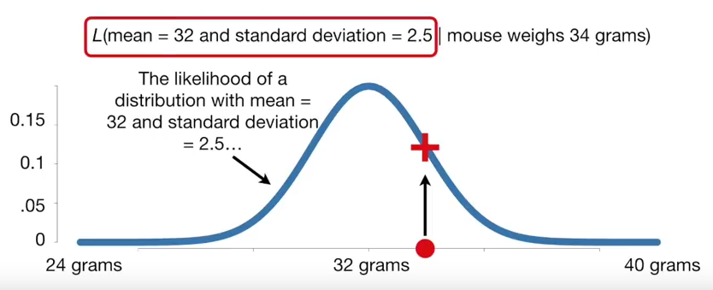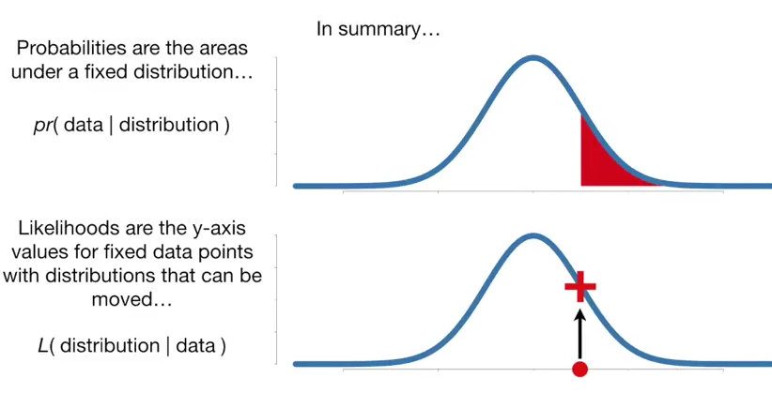

$$P\left(A | B\right)=\frac{P\left(B | A\right)*P\left(A\right)}{P\left(B\right)}$$

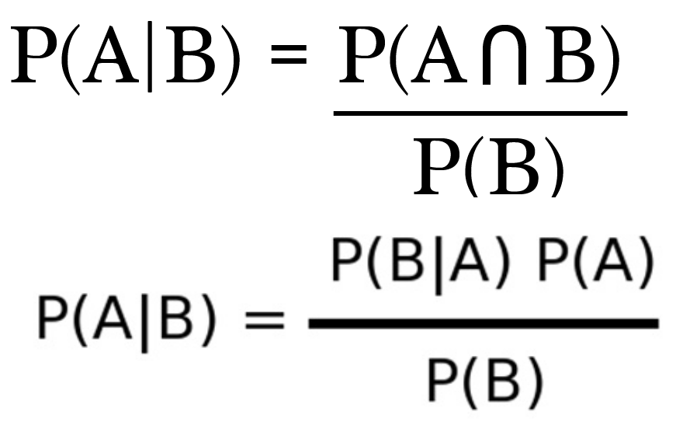

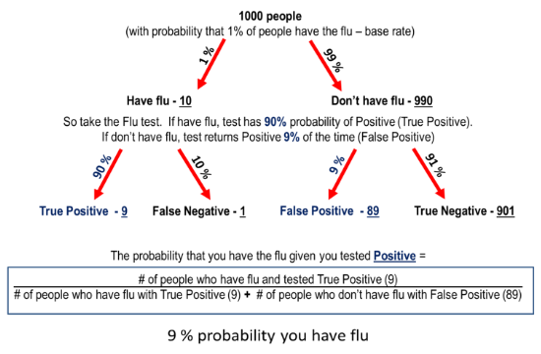

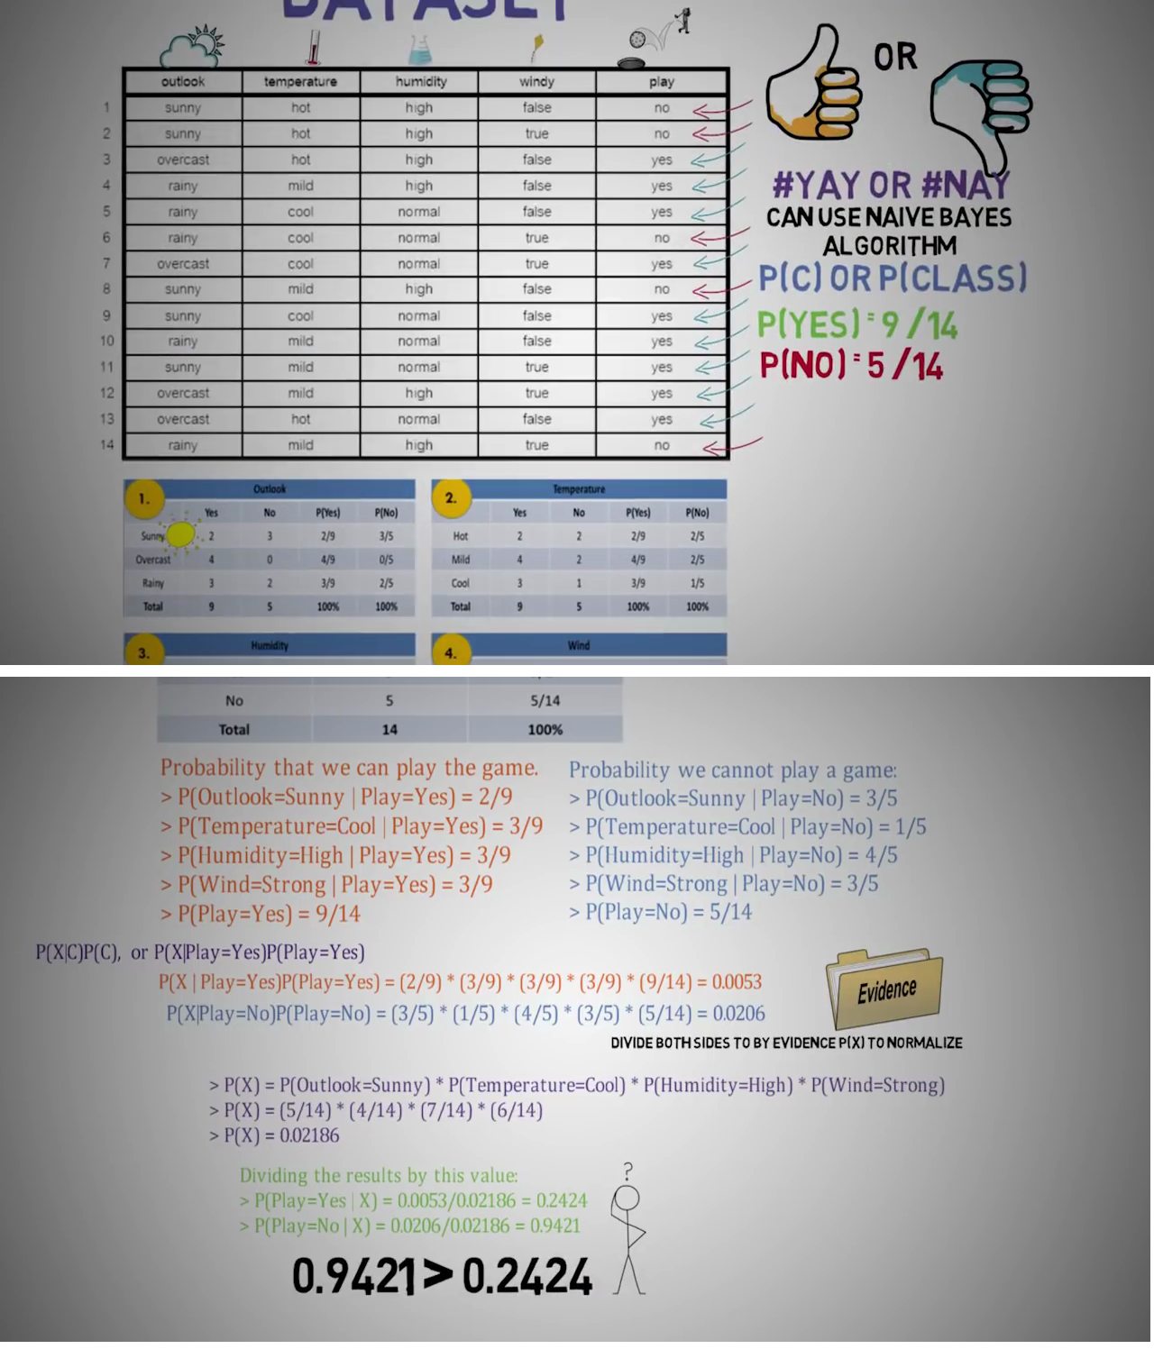

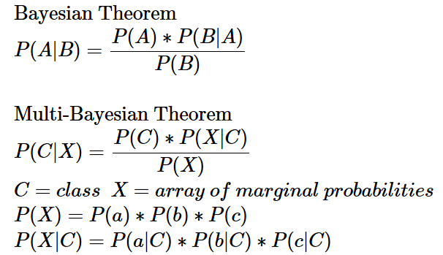

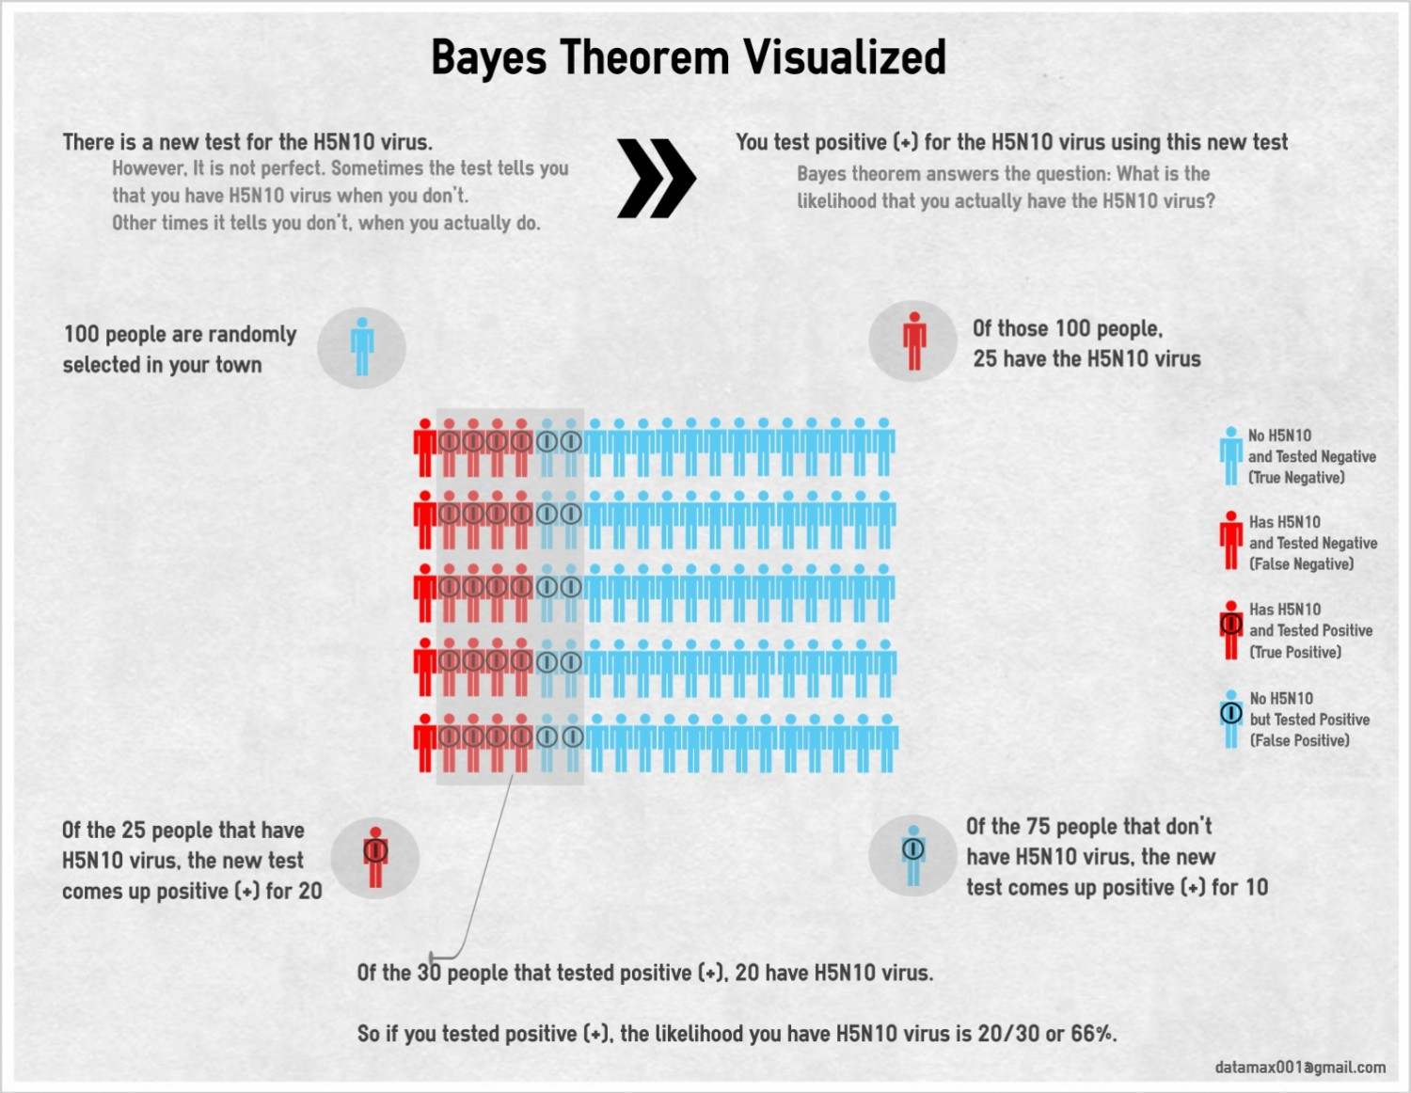



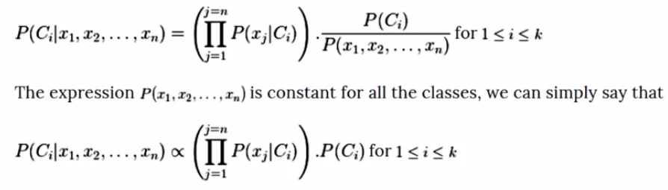

Practice Bayse Theorem with:

1. Wenn diagram
2. Table
3. Tree
4. 10 dots

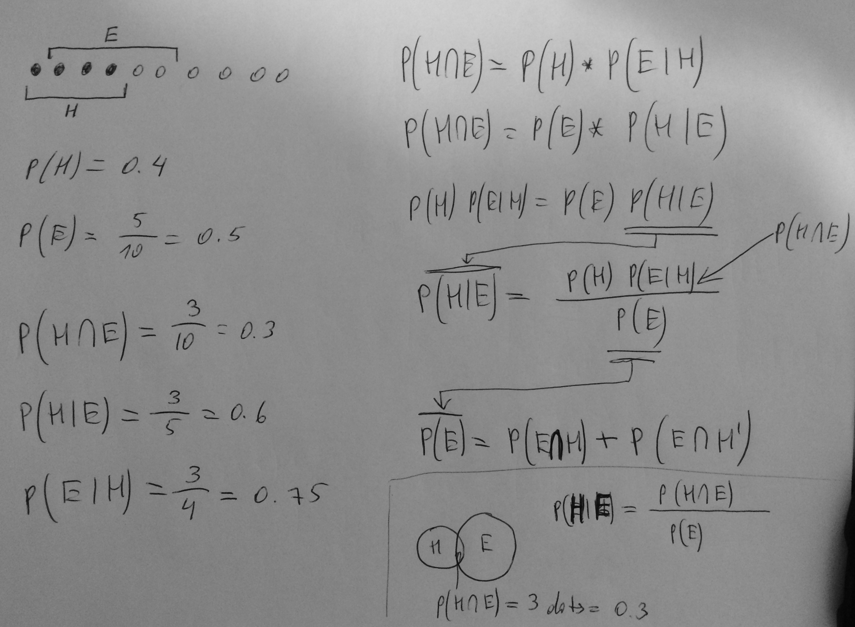

|  |  |  |  |  |
| --- | --- | --- | --- | --- |
|  | | **SUPERTEST - TRUTH** | |  |
| **H**  **Yes disease** | **H’**  **No disease** |
| **TEST**  **EVIDENCE**  **EXPOSURE**  **INTERVENSION**  **PREDICTION** | **E**  **Positive**  **Treatment/Intervention** | TP | **P(H|E)** = precision = posterior  **:**  FP  **:**  Type I = $α$ | **P(E)**  marginal probability |
| **E’**  **Negative**  **Control group** | FN  Type II = $β$ | TN |  |
| $$OR=\frac{TP:FP}{FN:TN}$$ | | **P(H)**  **P(E|H)** = sensitivity = likelihood  prior proposition |  |  |

